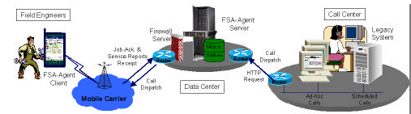
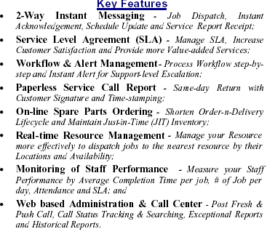

Recommended Business Flow for Field Service Support
Business Flow Diagram

